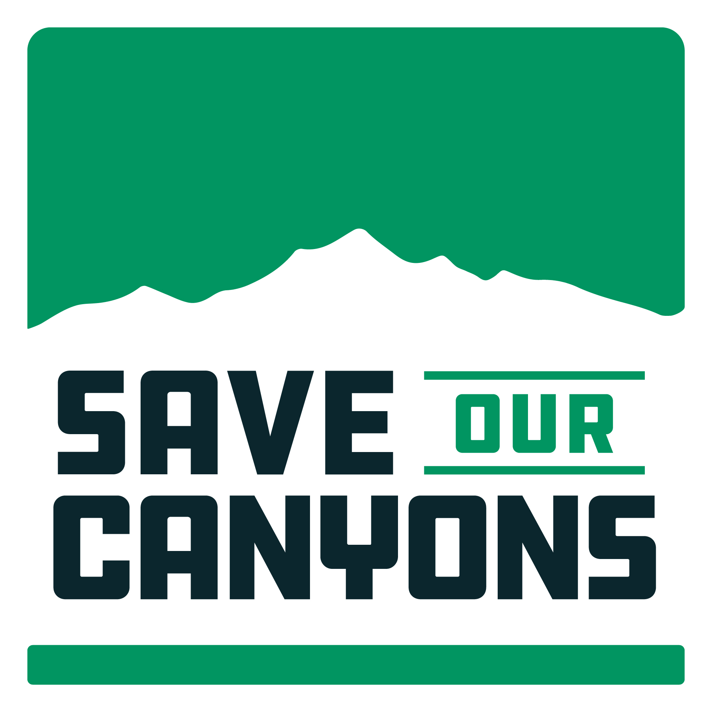

Dec. 9, 2021

Re: Millcreek FLAP Grant

Save Our Canyons is a Salt Lake County based non-profit organization dedicated to protecting the wildness and beauty of the Wasatch Mountains. Many, but not all, of our members use these canyons - including Millcreek - on a regular basis in a variety of ways.

For 50 years, we've been engaged in both advocacy and public planning processes in the Wasatch Mountains. Salt Lake County residents take great pride in our canyons, the opportunities to escape our increasingly urban environment - to sit, walk, hike, bike near streams, trees, exploring the intricacies of our canyons, for chances to observe the natural changes to these canyons and for that opportunity to engage with native species of plants and wildlife, but also others in our community out for a hike. No matter who we are or what we do, we are equals in these canyons. And as commercial pressures dominate the other canyons, there is no place that the equality is more present than in Millcreek Canyon.

Categorical Exclusion and Misalignment with Plans
To that end, we have several concerns with Millcreek project. From a process standpoint, we find it very concerning that the decades long call for a shuttle and transit projects in Millcreek Canyon, prompted Salt Lake County to pursue a Federal Highway Grant. No all money is good money, and we fervently believe that this source of money does not fit the purposes, intent, or vision articulated in the many plans and policies that govern this canyon. The 2003 Revised USFS Plan calls or increased transit and bus service and prohibits the creation of new parking. Numerous Salt Lake County plans and studies (2012 Millcreek Canyon Transportation Study, Wasatch Canyons General Plans) call for a shuttle program, as does the Mountain Accord. Adding insult to injury, SLCo and USFS and their Highway Partners expect to utilize a Categorical Exclusion to NEPA analysis. According to the White House Council on Environmental Quality, which was established to oversee actions under the National Environmental Policy Act (NEPA), a Categorical Exclusion (CE) "is a class of actions that a federal agency has determined, after review by CEQ, do not individually or cumulatively have a significant effect on the human environment and for which, therefore, neither an environmental assessment nor an environmental impact statement is normally required."

We are not sure how creating new parking lots in a watershed that is going to be used for culinary drinking water, when exhaustive science shows the impacts on widened roads, increased speeds (thereby increased collisions) and increased visitation do not "individually or cumulatively have a significant effect on the human environment" or the natural environment for that matter.

Section 4f Properties
The Millcreek Canyon roadway has numerous recreation sites on, along and immediately adjacent it. It is closed for well over half of the year to automobiles and gated. When snow covers the road, it is groomed for classic and skate skiing. When snow isn't present, the canyon is filled with bikes, walkers, runners, dogs, families, you even see people fishing from the road for recently restored native Bonneville cutthroat trout. Save Our Canyons holds wildflower hikes up the road, giving people who have disabilities or a hard time hiking on dirt trails, as this shaded canyon hosts exceptional wildflowers and native plant populations immediately adjacent the roadway and at unique sites like thousand springs. Visitors pay for recreation access to this canyon. As such we believe the entirety of the upper canyon (above the gate for sure) to be a 4f property where this proposal would create significantly greater impacts in excess of the de minimus requirement, provided by 4f protections. 4f properties are Parks, recreation areas, and refuges are three common types of properties protected by Section 4(f). To qualify as a park, recreation area, or refuge under the statute, a property must meet all the following criteria:

- It must be publicly owned
- It must be open to the public (except in certain cases for refuges as highlighted in the sections below)
- Its major purpose must be for park, recreation, or refuge activities
- It must be significant as a park, recreation area or refuge

If this doesn’t describe Millcreek Canyon, we don’t know what does.

Safety
We are additionally concerned about the impacts to safety arising from this proposal. Widening of the roadway, will increase the speeds which vehicles travel, regardless of the posted speed limit. Winding roads with limited sightlines naturally keep autos traveling at slower speeds. Currently, and according to the SLCo Millcreek Transportation study, the upper canyon has significantly less auto incidents as compared with the lower canyon that has wider road and improved sightlines. We are very concerned about this direction.

Improvements
This is not to say we are not in favor of some improvements in the canyon. We realize infrastructure must be maintained, be it a road, a trail, a path, a parking area, etc. It is the significance of the changes and their incongruence with the stated values in numerous plans, ordinances, local and regional processes that cause concern.

Following are a few ideas and concepts to consider as you look to alter the current state of Millcreek Canyon.

- Permit the parking in the upper canyon. Anyone that doesn’t have a permit for the 30-40 stalls at the top & other sites above winter gate is on foot, bike, or shuttle. Cabin owners are exempt.

- Reduce speed to 15-20 miles per hour above the winter gate (and enforce it). Our canyons aren’t for rushing around, we have cities, highways and interstates for that.

- Add bike racks at trailheads and picnic areas to help promote bike/ebike access to trails and picnic areas in the canyon and reduce the number of cars.
- Explore closing the upper canyon to automobiles on alternating days, similar to how city creek canyon, is managed.

- In the lower canyon, with Log Haven, Millcreek Inn and the Boy Scout Camps may warrant/need construction of a bike lane. In the upper canyon, a bike lane may not be needed if you reduce the number of cars. This does require a paradigm shift, where the car becomes the less desirable use, in deference to the bike. The solution is prioritizing people, not cars.

Each of our canyons is unique, but our concern is that this project harms the character, the unique nature and arguably the culture of Millcreek Canyon. Each canyon has unique challenges too.

We believe we need to do more to focus on people and connecting them to nature, rather than focusing on cars and their necessary infrastructure. We understand that a shuttle may come with some needed improvement, but this project, the project website talks nothing of a shuttle program. It says these improvements are for cars.

As our population grows, naturally by people who want to be nearer nature, we need to create more opportunities in harmony with nature. We aren’t creating more natural spaces — to the contrary, we are losing them at an alarming rate. We believe by placing emphasis on people and connecting them to the amazing sites in Millcreek Canyon through a shuttle program and through active transportation, we have a unique opportunity to actually create a new natural space, through repurposing existing infrastructure, that would add value to the canyon and our communities.

We recognize this takes a significant paradigm shift. Mass and micro transit systems must become part of our recreation experience. We want to help that happen, before it is too late. Please, don’t be like UDOT and pave our canyons - work with our community to save our canyons.

Thank you,
Carl Fisher

